**2024 Social Value Round-Up**

**Our Values**

In the modern business landscape, social value is important because it extends the focus beyond profit, emphasising a company's impact on its community, environment, and employees. By prioritising social value, businesses can build stronger relationships with their stakeholders, including customers, employees, and the wider community.

At DAY Project Management Ltd we pride ourselves on regularly giving back the community in areas we work and making social value a priority. All members of staff contributed in every way they could to our social value work, which is driven and focussed by our company values and sustainable development goals.

**Education, Employment & Skills:**

* **Reduced Unemployment & Social Mobility:** Education and skill development equip individuals with the knowledge and expertise required to enter the job market. By providing relevant work experience, skills and training sessions, we aim to help reduce unemployment rates, thereby contributing to economic stability and social wellbeing.
* **Economic Growth**: A well-educated and skilled workforce fosters economic growth but increasing productivity, innovation and competitiveness. We are a disability friendly employer, pay the living wage and are supporters of good employment in Greater Manchester.

**Wellbeing, Equal Opportunities, Diversity & Inclusion**

* **Enhanced Workforce Diversity & Inclusion:** Flexible working arrangements attract a more diverse work force. It allows people with disabilities, caregivers and individuals with other commitments to participate in the workforce more easily, promoting diversity and inclusion within organisations. We are a big advocate of women in construction and strive for a 50/50 gender balance.
* **Work-Life Balance**: Flexible working allows individuals to better balance their professional and personal responsibilities. Adjusting work schedules to accommodate commitments leads to reduced stress and improved wellbeing. We have a mental health first aider strategy group that meets quarterly to promote employee wellbeing and a healthy work life balance.

**Community Engagement, Charity Work & Donations**

* **Volunteering in the Community:** DAY PM encourages individuals to volunteer their time, skills and resources to support local initiatives and causes. Volunteering strengthens social bonds, promotes empathy and addresses community needs, such as donations for charities, cleaning public spaces, or volunteering our time with community groups.

**Environment**

* **Encouraging Sustainable Consumption & Lifestyles:** The DAY PM green team meet quarterly to review our carbon reduction plan. We aim to reduce carbon emissions by reducing waste, reviewing resource efficiency and encouraging green travel options and sustainable practices.
* **Reduced Commuting:** Flexible working often involves remote work or alternative work schedules which can reduce time and stress associated with commuting. This leads to cost savings, less traffic congestion and lower environmental impact due to reduced reliance on transportation.

**2024 Education, Employment & Skills**

This year, we attended a variety of schools & universities to take part in mock interview sessions, careers fairs, and activities to raise aspirations. We aimed to increase knowledge about different careers and show students the range of possibilities ahead of them, with a focus to improve social mobility and equality.

We have arranged several work experience weeks with students from Runshaw College, Stockport College, All Hallows RC High School and Trinity High School. The students benefitted from attending meetings, site visits, CV skills sessions and experienced the different aspects of the PM role.

Towards the end of the year, we attended Manchester City Council’s Brokering Relationships with Employers and Educators (BREE) launch event. BREE provides meaningful and structured relationships with schools to encourage young people to go into better employment. DAY PM have signed up to BREE, which will allow us to continue to demonstrate our commitment to providing real world insights for young people in 2025. This will enhance and build upon the work we already do to support schools with Gatsby Benchmarks 4, 5 & 6 (linking curriculum learning to careers, encounters with employers, & experience of the workplace).

*“During my work experience at DAY-PM, I loved gaining insights into the intricacies of project management in construction and the essential qualities required to excel as a project manager. It's safe to say that I will never look at a construction site the same way again.”**– Cindy, Key Stage 5 Student.*

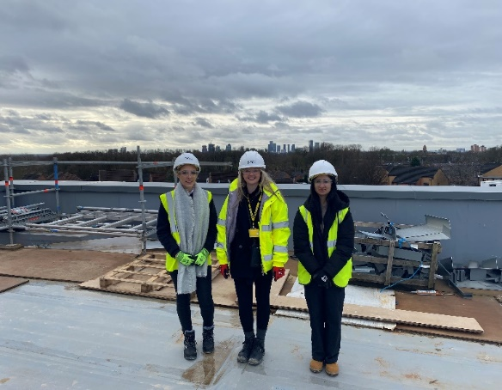

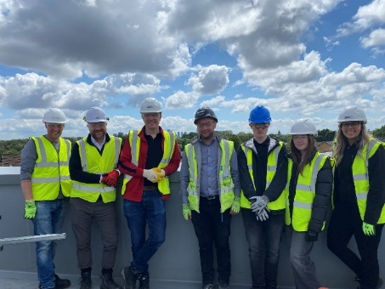

**2024 Wellbeing, Equality, Diversity & Inclusion**

DAY PM continue their commitment to prioritise mental wellbeing in the workplace, with 4 members of staff trained as Mental Health First Aiders with St John Ambulance. The mental health strategy group meet quarterly and provide mental health CPD sessions, wellbeing activities, drop-in support and an empathetic first point of contact for staff.

Donations and activities have taken place with the No.93 wellbeing Centre, Harpurhey. We have contributed towards the cost of travel for a walking trip and an afternoon tea and bingo afternoon for service users. We have also donated chocolate eggs and charitable funds for Greater Manchester Mental Health service users.

We have facilitated 2 successful site study events with Women in Property this year. As part of our regular donation activities, we have donated women’s smart clothing and office wear to Smart Works, a UK based charity that supports unemployed women in job interviews.

Throughout the year we have volunteered time with Project RECCE. Project RECCE create a smoother transition from ex-service personnel into the construction industry. We have supported individuals undertaking the Pathways into Construction course and shared insights and experiences, providing a practical view of a day in the life of a project manager.

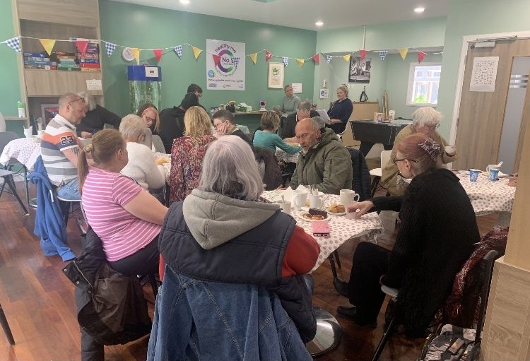

**2024 Community Engagement, Charity Work & Donations**

DAY PM have engaged with multiple community groups throughout 2024, including 13 donations or in-kind contributions. In June, we supported garden maintenance with the Chatterbox project, a community garden and food pantry. Then, in October we held sessions on CV writing and helped in the community shop at the Mustard Tree, a charity that creates opportunities to help improve economic wellbeing and find settled homes.

We also took part in 2 charity walks, both to raise money for hospital charities. In June, DAY PM, DAY Architectural and DAY Cost Management sponsored and supported the Cross Bay Walk to fundraise for Baby Beat. Baby Beat is part of the Lancashire Teaching Hospitals Charity and supported, babies, mothers and their families from across Lancashire and South Cumbria. The walk raised over £9000 for the charity, the best year yet for this event!

Following this success, we also took part in the 42 miles CDC Charity Walk from Skegness to Lincoln during August. This was to support the United Lincolnshire Hospital Trust to purchase an interactive ‘Kitten scanner’ for the new Community Diagnostic Centre. A kitten scanner is a miniature MRI scanner used to help reduce anxiety for young children needing an MRI or CT scan. Helping to reduce the need of administering general anaesthetic & sedation.

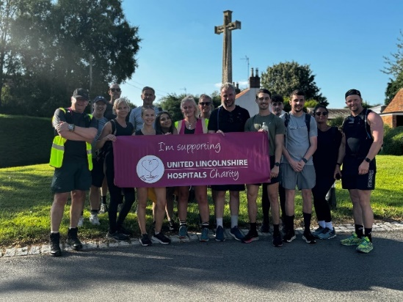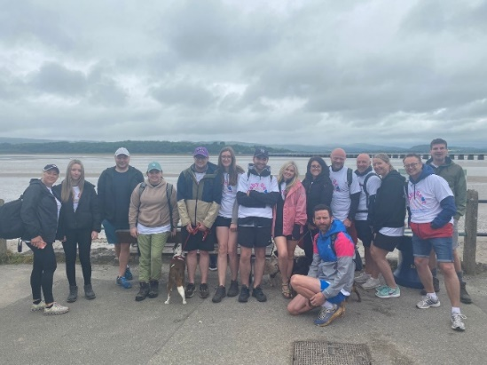

**2024 Environment**

At DAY PM we take part in annual volunteer days with Sow the City and engage with local community groups for planting activities & litter picking. Our new commitment: for every new build we complete, DAY PM will plant a tree.

During September, we attended a 3-day ‘Journey to Net Zero’ course with The Green Economy. The green team now meet quarterly to review carbon emissions and motivate sustainable action with all staff. We have developed a carbon reduction plan, with our net zero goals plotted against the 2023 baseline. Our net zero targets align with the Greater Manchester’s commitment, to be carbon neutral by 2038 and UK net zero by 2050. With initial goals to reduce our carbon footprint via reviewing resource efficiency, encouraging sustainable business travel, and to more accurately record scope 3 emissions using supply chain mapping.

With clients, we continue to contribute to sustainable building design through actively challenging the design on all our projects. This is to ensure we are building and retrofitting in the most sustainable way, in line with client’s aspirations & budget.

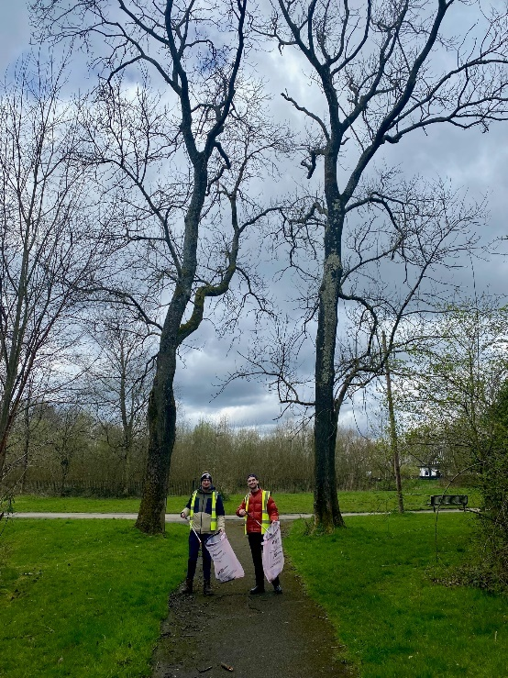

**National TOMs**

Using the National TOMs, to measure, track, manage, and improve our social value. We have estimated our social value generated during 2024.

**Acknowledgements**

The DAY PM team are very grateful to the many consultants, communities and charities that we worked with on social value activities during 2024. The positive impact made to the wider society would not be possible without their support.

